Infosys Springboard Virtual Internship 6.0 Completion Report

Team Details:

Batch Number: 1 Neurofleetx
Start date : 10-Nov-2025
Names:
- Tejas Thakor
- Ayush Kale
- Harshvarthini
- Subhashini Kandasamy
- Mehek Fatima Sheikh

Internship Duration: 8 Weeks

1. Project Title:
SmartDeliveryRoute(TrackMIle System)

2. Project Objective

SmartDeliveryRoute is a comprehensive web application designed to streamline logistics and last-mile delivery operations. The primary objective is to solve the visibility gap in traditional delivery systems.

Real-Time Tracking: To provide fleet managers with live visibility of drivers using GPS telemetry.

Automation: To automate the assignment of orders to drivers, reducing manual errors and dispatch time.

AI Analytics: To leverage Generative AI (Llama 3 via Groq) for analyzing driver history and generating automated performance reviews.

Scalability: To build a robust system using Spring Boot and MongoDB that can handle high-frequency location updates.

3. Project description in detail
SmartDeliveryRoute acts as a centralized platform connecting fleet managers (Admins) and delivery personnel (Drivers) through a responsive web interface.
The system is built on a Client-Server Architecture:
- Frontend (React.js): Provides two distinct consoles. The Admin Dashboard allows managers to create orders, view live maps, and generate reports. The Driver Console features a simulated navigation system where drivers update their status (Picked Up/Delivered) and location via checkpoints.
- Backend (Spring Boot): Serves as the "Nervous System," processing high-frequency API requests. It implements a Polling Mechanism to update the Admin's map every 5 seconds without page refreshes.
- AI Integration: A unique feature of SmartDeliveryRoute is its use of Large Language Models (LLMs). The backend sends raw delivery logs to the Groq API, which returns a natural-language summary of the driver's reliability and efficiency.
- Database (MongoDB): A NoSQL database was chosen to handle the flexible schemas required for nested location data (Latitude/Longitude) and rapid telemetry writes.
By integrating these technologies, TrackMile replaces manual phone-based tracking with a digital, automated, and AI-enhanced solution.

4. Timeline Overview
Week | Activities Planned | Activities Completed
Week 1 | Requirement gathering and architecture design. | Finalized "SmartDeliveryRoute" scope; selected Tech Stack (Spring Boot, React, MongoDB).
Week 2 | Database Schema Design and UI Wireframing. | Designed MongoDB collections (users, drivers); Created UI mockups for Admin Dashboard and Login screens.
Week 3 | Authentication Module (Frontend & Backend). | Built Login/Register UI pages in React; Implemented POST /register APIs in Spring Boot.
Week 4 | Order Management & Dashboard Development. | Developed Admin Dashboard UI; Built APIs for creating orders and assigning drivers.
Week 5 | Map Integration & Driver Console. | Integrated Leaflet Maps on frontend; Developed Driver Console UI for status updates.
Week 6 | Live Tracking Logic & AI Integration. | Implemented Polling Mechanism for real-time GPS; Connected Groq API for AI performance reports.
Week 7 | System Integration & Testing. | Linked React Frontend with Java Backend; Tested end-to-end flows (Order Creation → Delivery).
Week 8 | Final Debugging & Documentation. | Fixed Map rendering bugs and API errors; Finalized project report and presentation.

5a. Key Milestones
Milestone | Description | Date Achieved
Project Kickoff | Defined objectives, team roles, and full-stack architecture. | 17-Nov-2025
Database & UI Design | Finalized MongoDB schema and approved UI Wireframes. | 22-Nov-2025
Core Development | Completed React Admin Dashboard and Spring Boot REST APIs. | 14-Dec-2025
Live Tracking Alpha | Successfully synchronized Driver GPS updates with the Admin Map. | 29-Dec-2025
Final Submission | Submitted full source code and documentation. | 2-Jan-2026

5b. Project execution details

- Requirement Analysis: Identified the need for a real-time tracking system to replace manual logistics.
- Technology Selection: Chose Spring Boot for its dependency injection capabilities and MongoDB for its high-speed write performance.
- System Design: Architected the Layered Architecture to separate the Controller (API), Service (Logic), and Repository (Database) layers.
- Backend Development: Built secure REST APIs for "Driver Onboarding," "Order Creation," and "Live Telemetry".
- Data filtering: Implemented Java Streams to filter data efficiently, such as showing only "Today's Deliveries" on the analytics dashboard.
- AI Implementation: Integrated Groq API to process delivery data and return text-based insight
- Testing: Conducted rigorous API testing using Postman to ensure JSON responses were correct and error handling was robust.

6. Snapshots / Screenshots
Step 1 : User Authentication
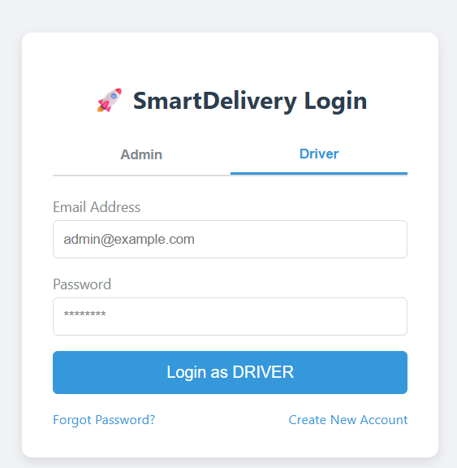
Figure 1 Role base login for Admin and Driver
Step 2 : Admin Dashboard
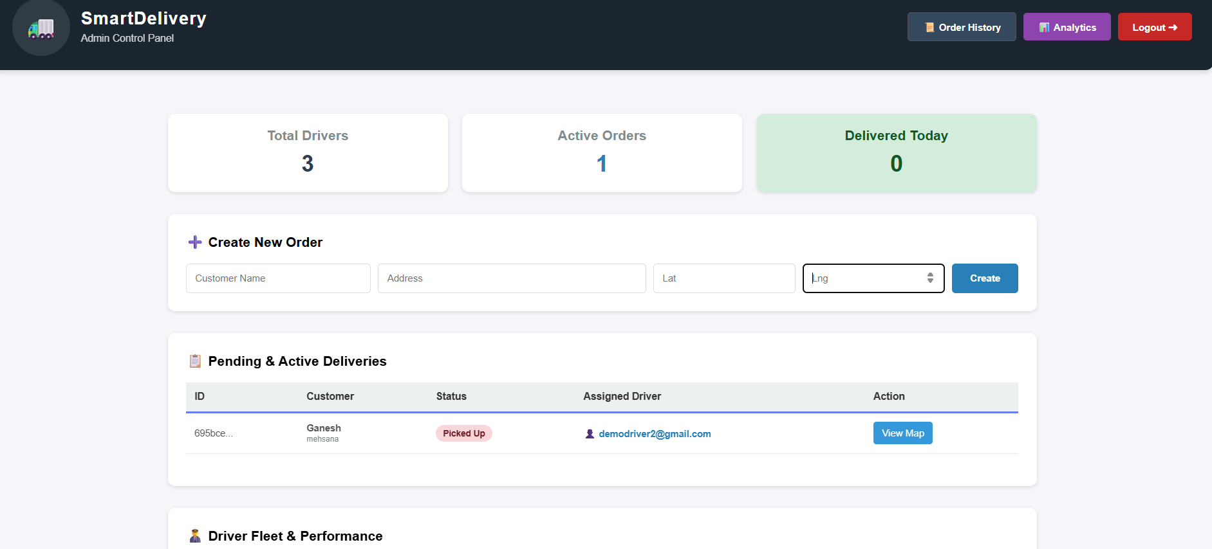
Figure 2Admin Dashboard showing active orders and fleet stats

Figure 3Admin Dashboard showing active orders and fleet stats

Step 3: Live Map Tracking
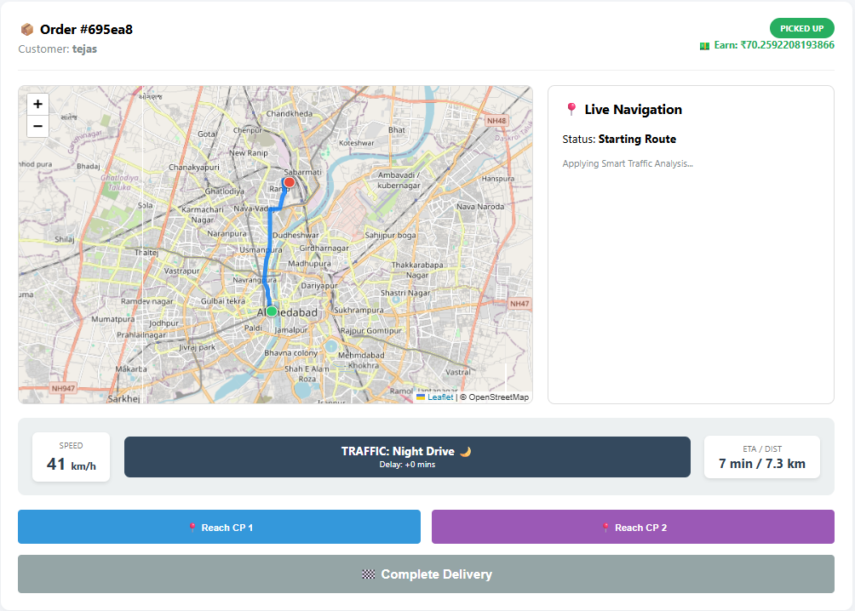
Figure 4Driver view with navigation checkpoints and status updates

Step 4: AI Performance Report
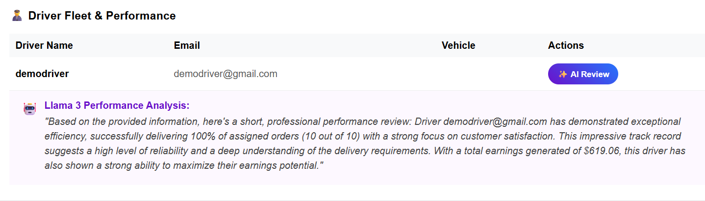
Figure 5Llama 3 generating a performance review for 'demodriver'

7. Challenges Faced
- Real-Time Latency: Ensuring the map updated instantly was difficult. We solved this by implementing an optimized Polling Mechanism that refreshes every 5 seconds.
- State Synchronization: Handling the complex state machine (Assigned -> Picked Up -> Delivered) required strict backend validation to prevent errors.
- AI Integration: Designing the correct prompt for the Llama 3 model to ensure it gave relevant, professional feedback based on raw data.
- Data Consistency: Managing the link between Orders and Drivers in a NoSQL database required careful schema design
8. Learnings & Skills Acquired

- Full-Stack Development: Mastered integration between React.js (Frontend) and Java Spring Boot (Backend).
- Geospatial Data Handling: Learned to work with Leaflet.js and map coordinates for real-time visualization.
- Generative AI Application: Gained hands-on experience using Groq/Llama 3 APIs to analyze structured data.
- NoSQL Database Design: Improved skills in designing MongoDB schemas for flexible, nested data structures.
- Team Collaboration: Coordinated effectively to separate Admin vs. Driver module development tasks.

9. Testimonials from team

Tejas Thakor (Backend Lead): "Architecting the Spring Boot backend taught me the importance of scalable API design for real-time applications."

Ayush Kale (Ai): "Working on the React frontend gave me deep insights into state management and dynamic map rendering."

Harshvarthini (Frontend): "Integrating the AI model was a highlight; seeing raw data turn into human-readable reports was fascinating."

Subhashini Kandasamy (Frontend Lead): "Designing the MongoDB schema helped me understand how to structure data for efficient retrieval in logistics."

Mehek Fatima Sheikh (Frontend): "Building the Driver Console taught me how to create user-friendly interfaces for mobile-first users.

10. Conclusion

SmartDeliveryRoute successfully demonstrates how modern web technologies can revolutionize logistics. By combining Spring Boot's reliability with React's interactivity and AI's analytical power, the system provides a holistic solution for managing deliveries. The key achievement is the seamless synchronization between the Driver's actions and the Admin's live view. The project not only solved the core problem of visibility but also introduced intelligent automation through AI reporting.

11. Acknowledgements
Thanking the organization, mentor, and myteam members who supported your internship journey.
I would like to express my sincere gratitude to Infosys for providing me the opportunity to work on the SmartDeliveryRoute and gain hands-on experience in AI and ML applications.
I am especially thankful to my mentor, Vinay Prasant Sir, for their constant guidance, support, and valuable insights throughout the internship. Their mentorship helped me overcome challenges and grow both technically and professionally.
I would also like to thank my team members for their collaboration, encouragement, and efforts in successfully executing this project. Their teamwork made the internship journey smooth and enriching.
Finally, I appreciate everyone who contributed directly or indirectly to my learning and the completion of this project.

